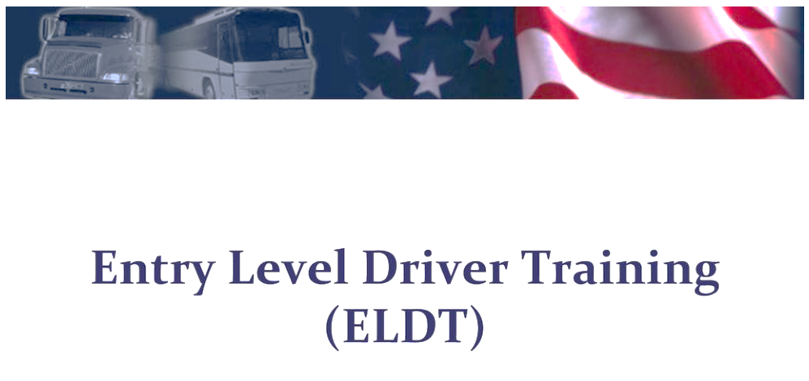

ORIENTATION

# Introduction

This course will expose you to the fundamentals of the trucking industry. The qualifications you must meet and some of the phrases you must grasp are controlled.

# Trucking is critical

Welcome to the trucking sector. The trucking industry is critical to the economy of our country. Trucks transport everything from raw materials to manufacturers to finished products to warehouses, stores, and homes. Trucks practically convey seed and fertilizer to farms, as well as food to our nation's stores. A truck transports everything at some point.A notepad with a clock and paper clips

According to the American Trucking Associations, trucks transported 10.42 billion tons of freight, principally exports, in 2016. This accounts for more than two-thirds of total domestic tonnage carried. Over 7 million people are employed in trucking-related jobs throughout the economy, including 3.5 million drivers.

# Intrastate versus Interstate

A motor carrier may operate in Interstate commerce, intrastate commerce, or both. To determine whether transportation is intrastate or Interstate, two factors must be examined. The first is the movement of the driver's vehicle and its contents, followed by the intent and movement of the shipment. The trucking sector is subject to government regulation, which is meant to safeguard the safety of people working in the industry as well as the general public. Knowing and adhering to the regulations that influence you and your sector is an important part of being a professional driver.

# Administration for Motor Carrier Safety

# Federal Motor Carrier Safety Administration - Wikipedia

The federal motor carrier safety administration is an agency of the United States Department of Transportation that issues and enforces the majority of the regulations that Interstate motor carriers and drivers must follow. These regulations are commonly referred to as the federal motor carrier safety regulations. They establish basic safety rules and standards for motor carriers and commercial motor vehicles.

# Subjects covered

Qualification and disqualification of drivers working hours, commercial driver's license requirements, testing for drugs and alcohol, Vehicle maintenance and inspections.

Most data that at least some of the FMCSRS for intrastate operations because requirements vary from state to state it is your responsibility to understand the regulations of the state you'll be traveling in before you hit the road. The pipeline and hazardous materials safety administration is an agency of the USDOT that issues and enforces the hazardous materials regulations or HMR. When hazardous materials are offered in commerce for transit to and transported by rail, air, motor vehicle, and vessel carriers, the regulations apply.

Drivers and carriers for interstate, intrastate, and overseas carriers are also responsible for adhering to other industry requirements, such as workplace safety.

# Laws governing the environment and taxes

In addition to complying with the FMCSRS at HMRs and other industry laws. You are also subject to state and local laws and regulations, which range from speed restrictions to idling time. It is critical that you are informed of and observe the requirements for the locations in which you travel. To become a professional driver, you must obtain a commercial driver's license. To do so, you must first obtain a commercial learner's permit.

# Learner’s permit for commercial purposes

# Paper Driving Learner's Permit Learning Test, PNG, 648x969px, Paper, Area, Banner, Book, Brand Download Free

CLP permits behind-the-wheel training on public roads and highways. To obtain a CLP, you must be at least 18 years old and pass a general knowledge test for the vehicle class you intend to drive. If the vehicle you will be driving is a combination or has air brakes, you must additionally pass a written test for a combination vehicle and air brakes. There are other conditions that must be satisfied as part of the CLP application process, including verifying that you are not subject to disqualification for, giving proof of citizenship, and completing the CDL.

When operating a cmv, the CLP holder must always be accompanied by the holder of a valid cdl who has the proper class and endorsements necessary to operate the CMP. The cdl holder must directly supervise the CLP holder by being in the front passenger seat of the vehicle next to the CLP holder. A CLP holder is not eligible to take the cdl skills test in the first 14 days after the issuance of the CLP. You will also be required to give documents and papers comparable to what you provided when you applied.

You requested your CLP. For more information, consult your state's licensing agency's CDL manual. The cdl classes, also known as groups, are determined by the vehicle's gross vehicle weight rating or gvwr or gross combination weight rating or gcwr. The classes and groups are displayed on your screen. If you intend to operate some specialized types of vehicles, you must receive an endorsement on your CDL.

# Endorsements

# Commercial Driver's License (CDL) Endorsements & Requirements - Pages

If you intend to drive a CMP that needs a CDL endorsement, you must take and pass a specialized written and/or skills test for each endorsement. The only endorsement permissible on a clp are passenger, school bus, or tank. You must also meet Transportation Security Administration (TSA) requirements to receive a hazardous materials endorsement. This includes submitting to criminal history and intelligence-based background checks, as well as giving proof of citizenship or lawful permanent status. limits may also be imposed on your CDL for a variety of reasons.

Airbrake intrastate only vision glasses contacts and manual transmission are examples of frequent limits that may be imposed on a driver's CDL. On a CLP or CDL, restrictions are typically assigned a letter or number and accompanied by a brief explanation. As you will discover throughout this course of instruction, there is more to becoming a professional driver than simply obtaining a CDL and hitting the road; there are additional regulatory qualifications you must meet in order to operate a cmv.

# Qualifications for drivers

You must also be knowledgeable with cargo securing methods and processes in order to assess if the goods you transport is correctly loaded, distributed, and secured. Several parts of the FMCSARS discuss cargo securing, and you are not considered physically competent. You may not drive a cmv if you use certain drugs or dangerous substances; however, there is an exception that allows you to use such a drug or substance if prescribed by a doctor who is familiar with your medical history and assigned duties, and who has advised you that the prescribed drug or substance will not impair your ability to safely operate a cmv. A medical exam performed by a Medical Examiner listed on the national registry of certified medical examiners is required to drive a CMV if the Medical Examiner finds that you are physically qualified to operate a cmv, you will be given a medical examiner's certificate after initial examination you are required to have another exam every 24 months or after you have suffered a disease or injury that affected your ability to drive a cmv .If the determination of whether you are physically qualified to drive a c and b is delayed pending the receipt of additional information or further examination the examiner must inform you that the additional information must be provided within 45 days and that the pending status of the exam will be reported to FMCSA. When you apply for a CLP or cdl you must turn in a valid copy of your medical examiner's certificate and documentation certifying that you drive under one of four categories non-excepted Interstate accepted Interstate non-excepted Interstate or accepted intrastate to your driver Licensing Agency this information will be maintained on your driving record. You will not need to self-certify again unless you renew your upgrade and endorsements two or are degraded to a non-cdl class. Part 3 91 subpart e of the FMCSA requires motor carriers to keep a driver qualification or DQ file for each driver they hire.

# File containing driver certification information

The materials listed below must be included in your driver qualifying file.

## Employment application

MVR (motor vehicle record) issued by the state. a road test, a road test form and certificate, or a copy of the driver's license or road test certificate, are allowed. On-CDL drivers must have an original or a copy of their medical exam certificate.

CLP cdl drivers' NVR provides current medical certification status and self-certification information from states on an annual basis. Notes regarding your driving record's annual review. The driver's annual list of infractions. Letter stating that the Medical Examiner who granted your medical examiner's certificate is on the NRCME

If applicable, SPE certificate medical exemption or medical variations document. Your DQ file must be kept by your employer for the duration of your employment and for three years after you leave. As a professional driver, this qualification is a serious issue. A driver holding a CLP or cdl can be disqualified from driving a cmv if convicted of certain offences while driving any type of vehicle. This includes our personal vehicle.

## Serious offensesCommercial Drivers Face Harsh Penalties for DUI | Griffen & Stevens

If you are convicted of any of the following significant offenses while driving a CMP, you are barred from operating one. Having a blood alcohol content of 0.04 or higher, When your CDL is revoked, suspended, or cancelled as a result of prior offenses while operating a CMV, or you are disqualified from operating a CMV. The negligent operation of a CMV results in a fatality.

Using a cmv to commit a criminal involving specific categories of human trafficking.

If you are guilty of any combination of two or more of the following serious traffic infractions while driving any vehicle, cmv or non-cmv, you are barred from operating a cmv. Excessive speeding is defined as exceeding the posted speed limit by 15 miles per hour or more. Driving recklessly. Making erroneous or unpredictable traffic lane shifts., following the vehicle in front of you too closely. Other than a parking offense originating from a fatal accident, breaking a state or local legislation relating to motor vehicle traffic control.

A motorist who is convicted of two or more significant traffic infractions while driving a non- cmv is disqualified only if the conviction results in the driver's driving privileges being revoked, cancelled, or suspended.

## NOTE

A driver who is convicted of two or more serious traffic violations while driving a non-cmv is disqualified only if the conviction results in the revocation cancellation or suspension of the driver's driving privileges. During a trip, you may be placed out of service by an enforcement officer for a certain period of time or until the given problem has been corrected. This typically occurs at a weigh station and or during a roadside inspection conviction for violating such an omission Drivers of passenger vehicles and those delivering dangerous products face harsher penalties. Part 382 of the FMCSA addresses alcohol and drug use by commercial motor vehicle drivers. The regulations' goal is to prevent accidents and injuries, that are the result of a driver using alcohol or drugs. Your employer may ask you to report any therapeutic drug use failures. If you test positive for drugs or refuse to undergo mandated alcohol and/or drug tests, you will be removed from all safety-sensitive duties until you complete your return to duty process. Throughout your driving career, you may be required to operate a variety of CMVs. You go through a return to duty process. There are many different types of cmvs that you may be required to operate over your driving career. The slides below are a summary of some of the basic tractors.

# Tractor

The tractor is the power unit that is used to pull a vehicle or vehicles trailers semi-trailers tankers flat beds etc. There are two cab styles that are most common the conventional tractor and the cab over engine, with a conventional tractor the engine is located under the hood of the tractor like Passenger vehicles the engine is in front of the driver with a cab over engine tractor the cab is located over the engine the driver is over the front wheels and the front of the tract The trailer stores and transports the goods; there are two sorts of trailers: full trailers and semi-trailers. A full trailer is supported by its own axles; no weight is held by the towing vehicle, whereas the front of a semi-trailer is supported by the tractor, notably the tractor's fifth wheel.

When a semitrailer is detached from the truck, it is Friday and sits on legs known as landing gear. The fifth Wheel is a coupling mechanism positioned at the tractor's rear frame that is used to connect the trailer's front to the tractor. It resembles a flat rounded plate with a V-shaped slot. Duals are a pair of wheels and tires installed on the same side of one axle. When a trailer is linked to a tractor, it is referred to as a combination vehicle. The steering axle is the front axle that controls the vehicle's direction. The drive axle or axles are the axles that are propelled and actively pull the load, and a tandem axle is a pair of axles that can be found on a tractor or a trailer. When driving a CMP, you must consider the vehicle's length, weight, and height. The Federal Highway Administration oversees big Truck and Bus size and weight restrictions in the United States. The federal size and weight limits are established in 23 CFR 658 truck size and

weight route designations length width and weight limitations. The federal size and weight limits apply to the national network of interstates, which includes Interstate highways and federal aid highways.

In addition to federal regulations, each state has rules addressing legal vehicle size and weight. These laws address the legal limit for weight, height, length, and breadth of cars and or trailer configurations. In addition to the federal weight limit, the federal Bridge formula establishes the maximum weight any set of axles on a motor vehicle may carry on the Interstate highway system dim the intent is to limit the wait till length ratio of a vehicle crossing a bridge to reduce the risk of bridge damage.

# The formula for a bridge In the bridge equation

W is the maximum weight in pounds that can be carried on two or more axles, rounded up to the nearest £500.L is the distance in feet between any two or more consecutive axles' outer axles. N is the number of axles under consideration. The bridge formula takes two elements into account: the number of axles necessary to support the vehicle's weight and the distance between the axles. To ensure compliance with the bridge formula, you must first determine the actual weights on each axle group and measure the axle spacings on your vehicle. Check axles 1 through 5, 1 through 3, and 2 through 5 and ensure each axle group complies with the weight limits provided in the bridge table.

Assume you were given a scale ticket with the following information: steer axle weight is 10620 pounds, drive axle weight is 32740 pounds, trailer axle weight is 33600 pounds, and gvw is

76960 pounds. With this information, you do not need to perform complex calculations using the bridge formula because the values in the bridge table are the results of various axle spacing calculations. To begin, check axles 1 through 5 axles 135 are 51 feet apart under column and in the bridge table find the number 51 then look under the 5 -axle column the maximum weight for five axles 51 ft apart is £80000 your vehicle is 76960 pounds and the gross vehicle weight is in compliance then check axles one through three steer axles and drive axles one through three are 20 ft apart According to the table, the maximum weight for four axles 35 part is 65500 pounds axles 235 are carrying 66340 pounds because your actual weight is greater than what the bridge table allows you to remove wait redistribute wait or increase the distance between the axles .Using the bridge table for the driving axles and trailer axles, if possible, is significantly easier than working through the bridge formula as mentioned.

# Station for Weighing

A weigh station is a facility staffed by law enforcement that is equipped with expertise to ensure drivers and their vehicles are in compliance with size and weight loss requirements. When it comes to stopping at a weigh station, each state has different requirements. Some states require all trucks to stop, while others require vehicles over a certain weight to stop. If in doubt, stop at the weigh station. It is better to be safe when it comes to this issue because there can be severe penalties for illegally bypassing a weigh station. Law enforcement frequently uses weigh stations to conduct roadside inspections, which ensure that you and your vehicle are functioning in a safe and legal manner. While there is no federal height restriction, it is crucial to remember that you will have to deal with overhead clearance constraints at times. Never assume the post and hide is correct when passing under bridges and overpasses, and never think what is mentioned on your road atlas or global positioning system for GPS is accurate. When in doubt, take another path.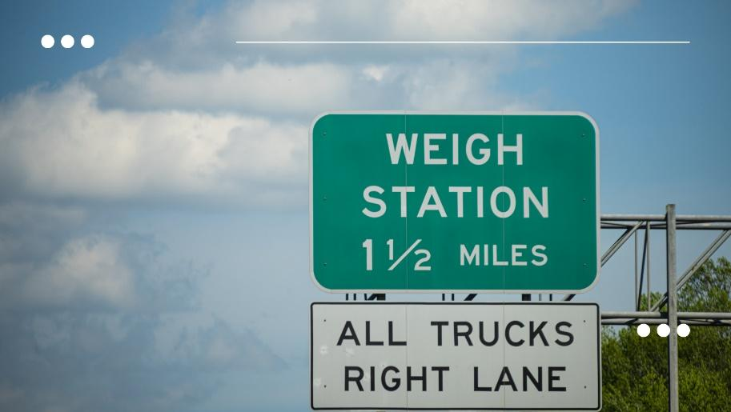

The settling of pavement repaving resurfacing or packed snow can change an overhead clearance.

# SUMMARY

You should now be able to

* identify the regulatory agencies in charge of the trucking business and explain the significance of adhering to applicable laws and regulations.
* Describe the process of acquiring a commercial driver's license, as well as the required driver credentials and what constitutes a disqualification.
* Discuss alcohol and drug prohibitions, as well as the types of testing that drivers should expect in certain situations.
* Recognize the main components of a combination vehicle, as well as the size and weight restrictions imposed for travel on the national network.